Open the "Foodmart_Data_Model.xlsx" worksheet that you saved on your desktop. This file was the finished product of your previous exercise. If you have not completed Quest #1 and Exercise 2.1, please take care of those deliverables first.

Click Data, and then Queries and Connections to show its pane. You should see Customer-Lookup with 10,281 records loaded. This was what you did in Quest #1.

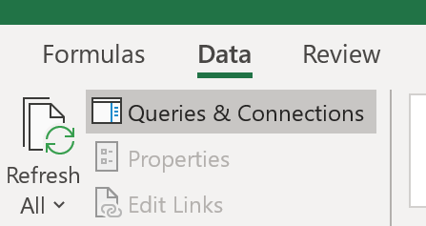



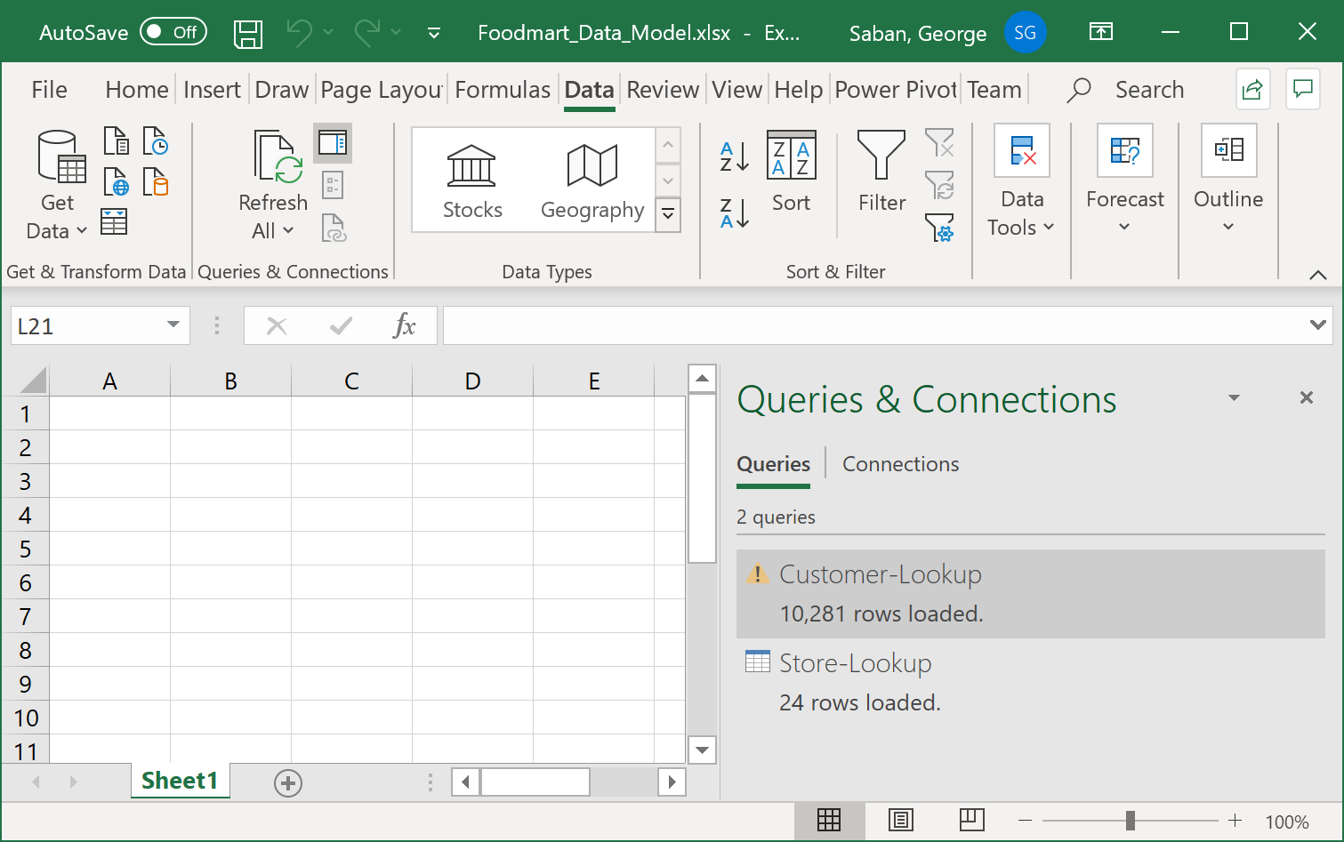



Note that you have loaded two files so far.

Now let's load our third file, the Product-Lookup.csv. Click Data, arrow-down of Get Data, From File, From Text/CSV

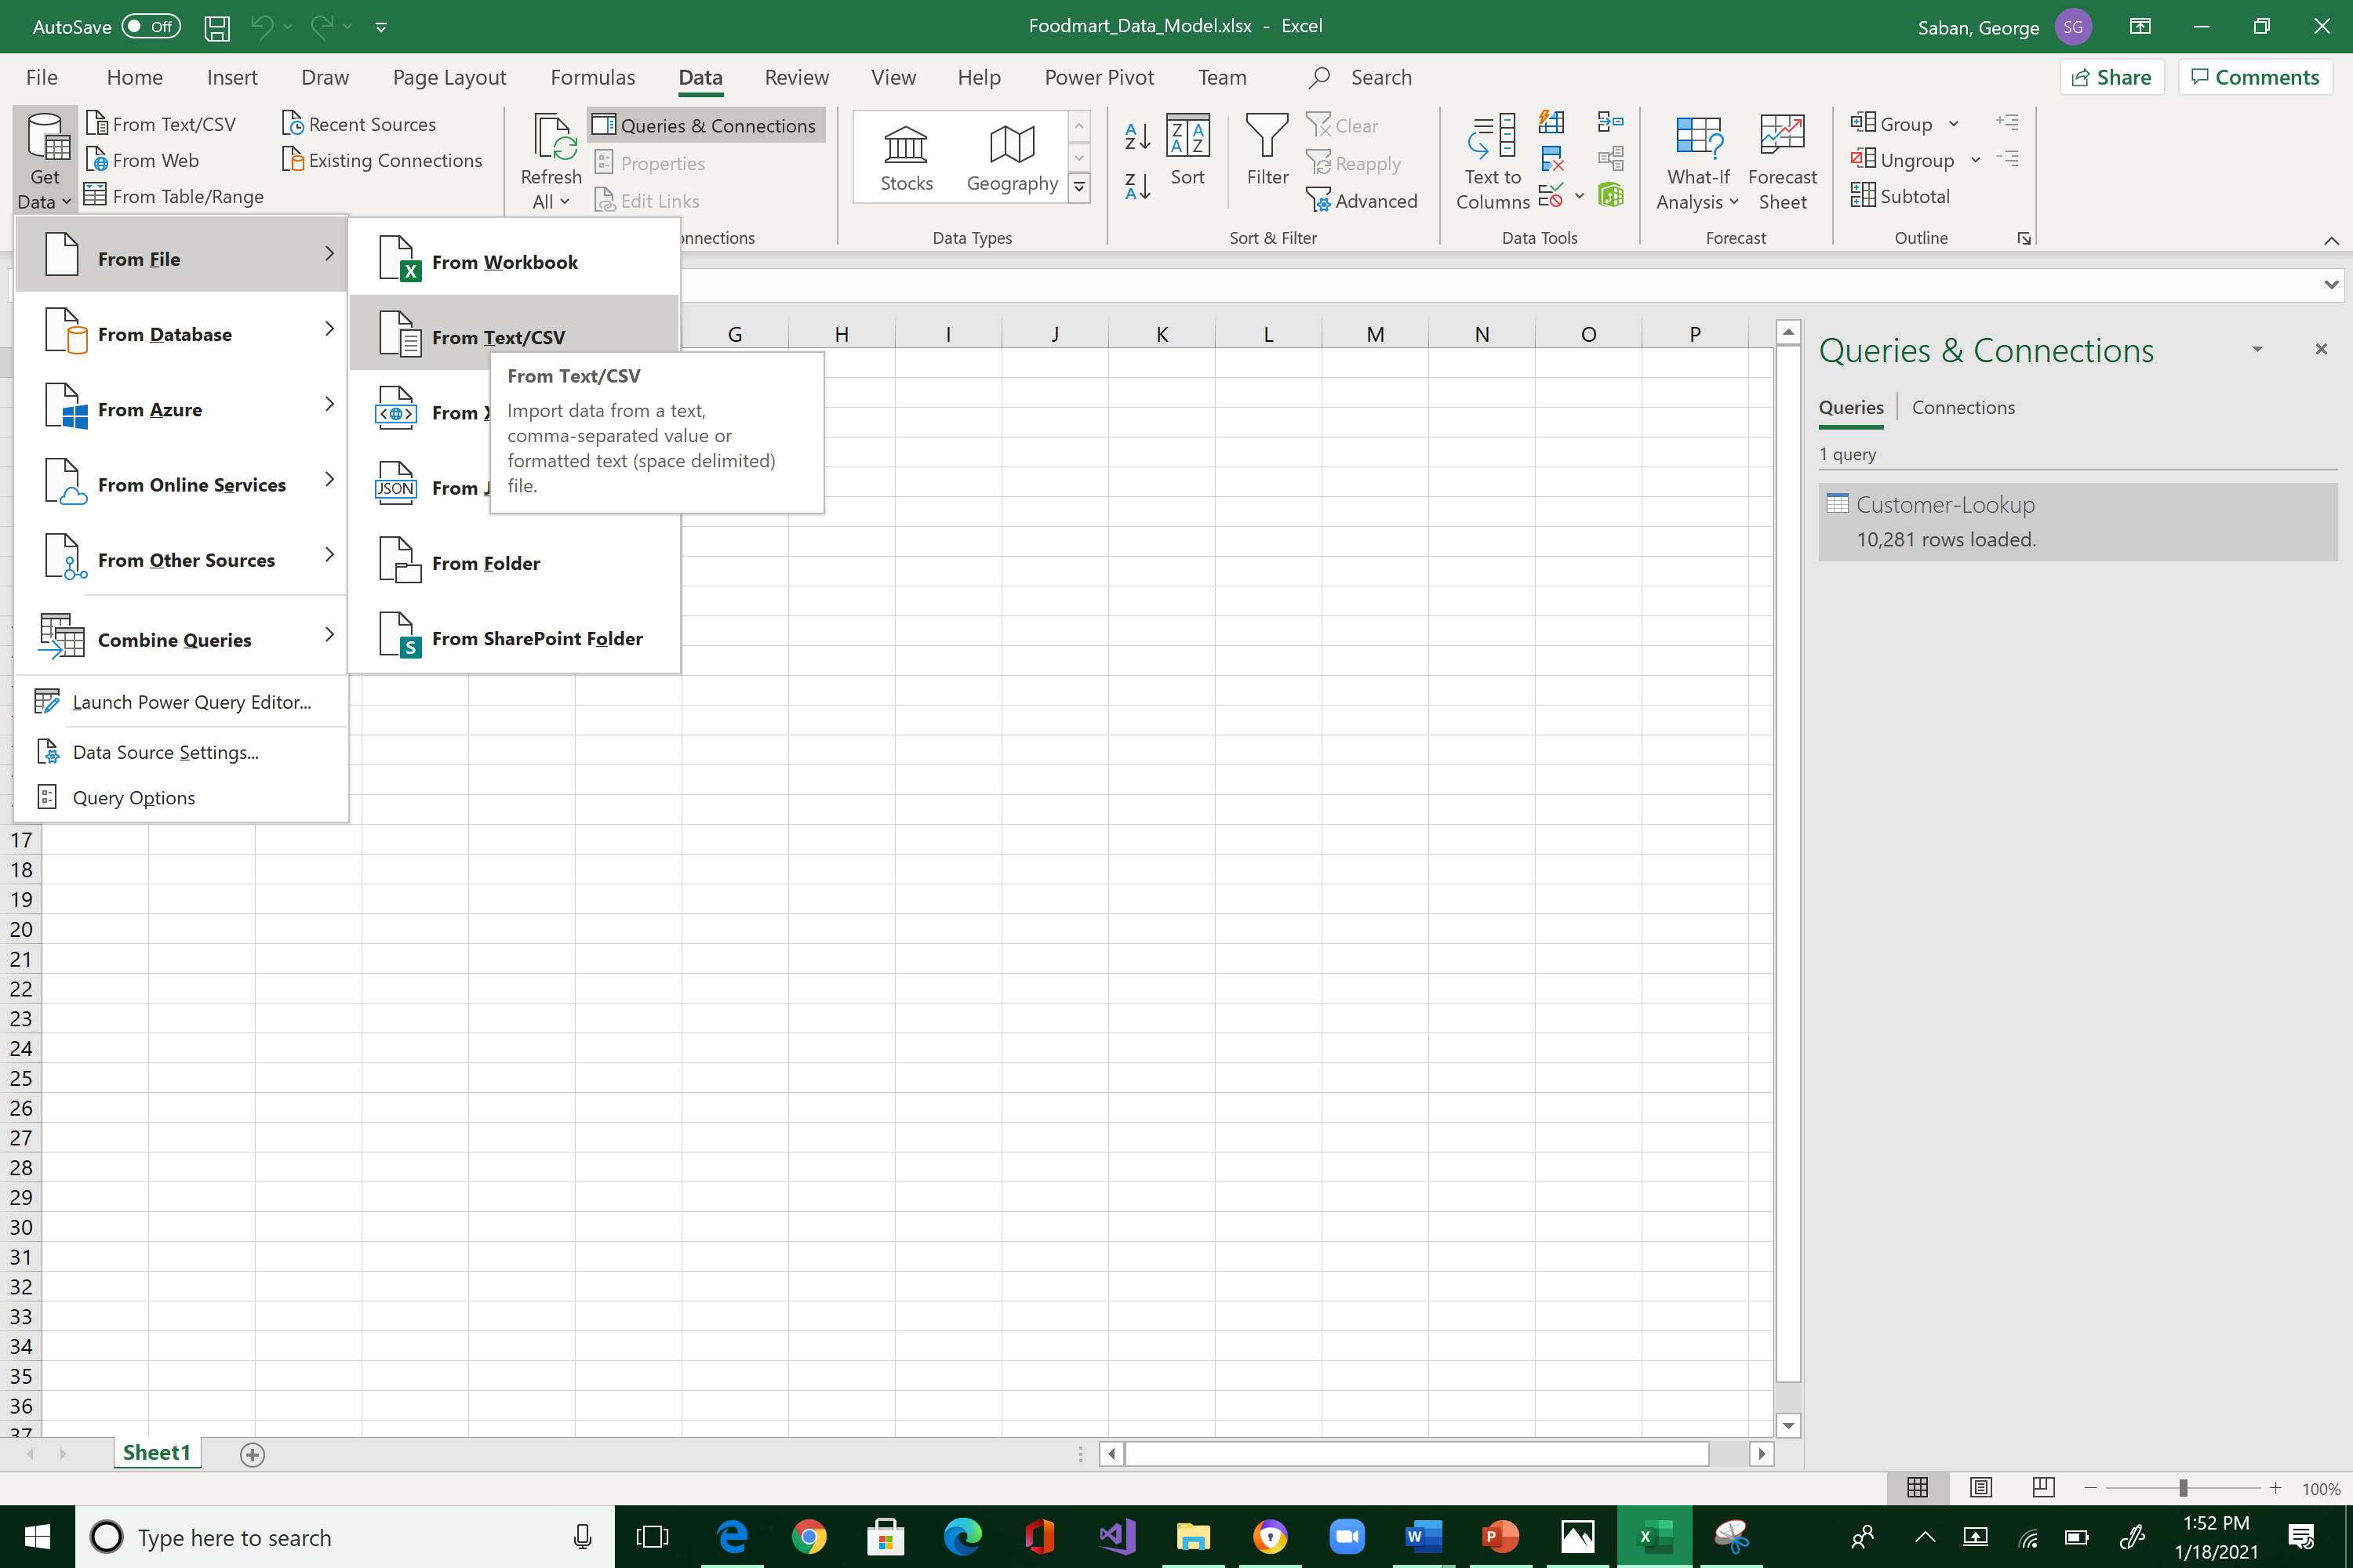



Navigate to where you store "FoodMart Data" (the files that you downloaded from Canvas last week) and select "Product-Lookup.csv ".

You will see the import preview interface below. This is the window where we do data shaping, filtering, and transformation. From here, by default, you would always want to select Transform Data. So, click it!

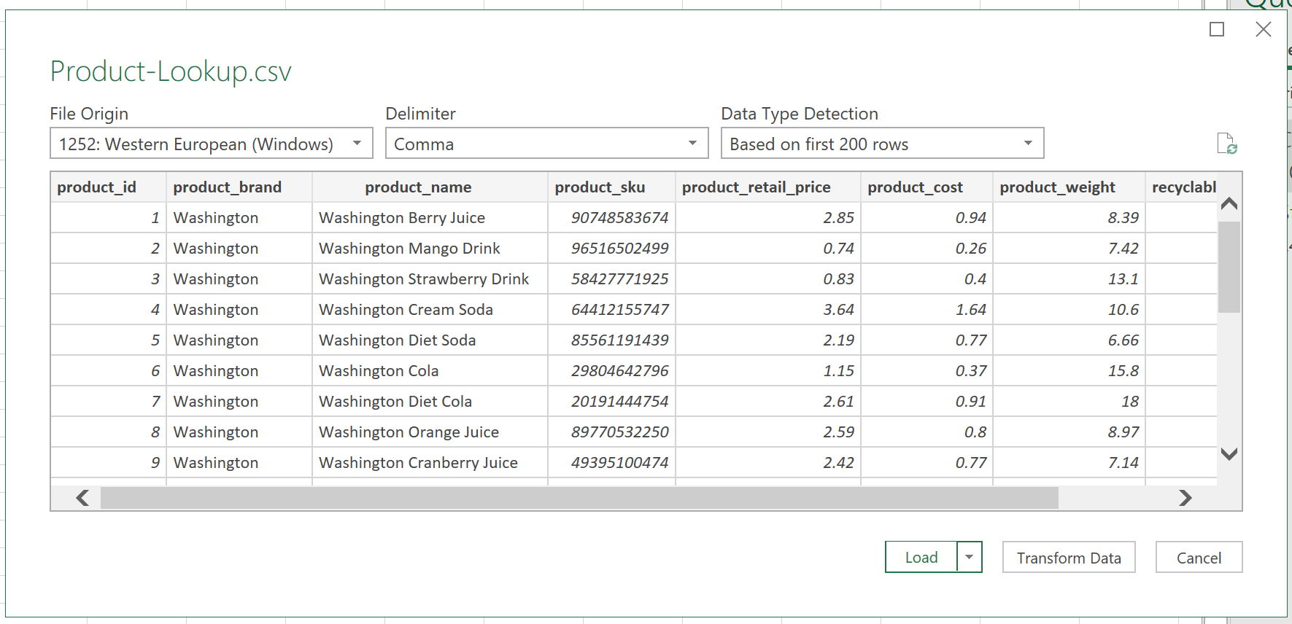



Same process:

1. Check the table name
2. Check if the column headers is what you want
3. Check the data types per column

The Product_Lookup worksheet gives us relevant data regarding products.

Let's change the data type of product_sku because we will never do mathematical operations against it. Change from number to Text by clicking on the type icon. And click Replace current the steps that Excel executed on its own.

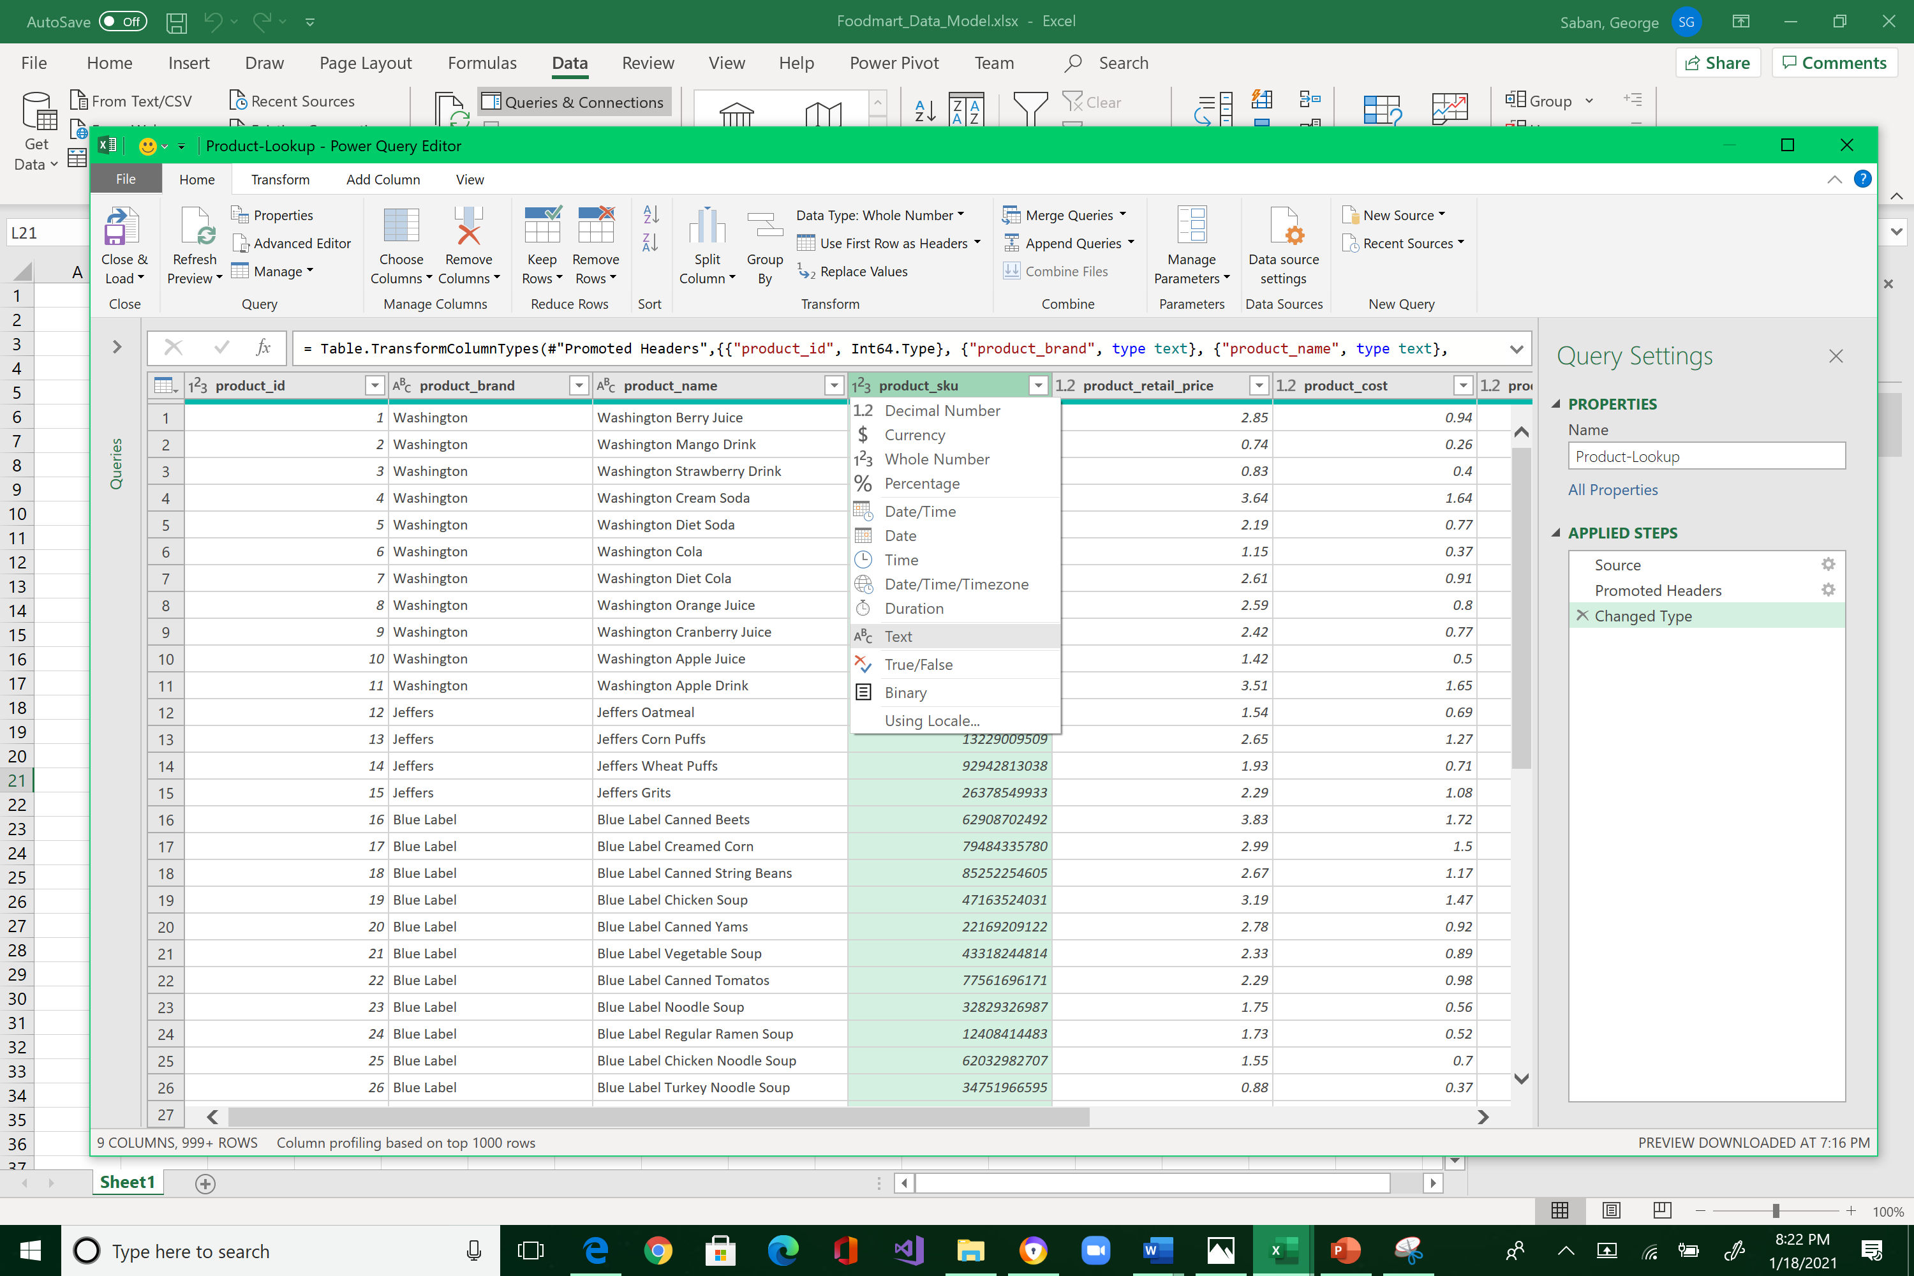



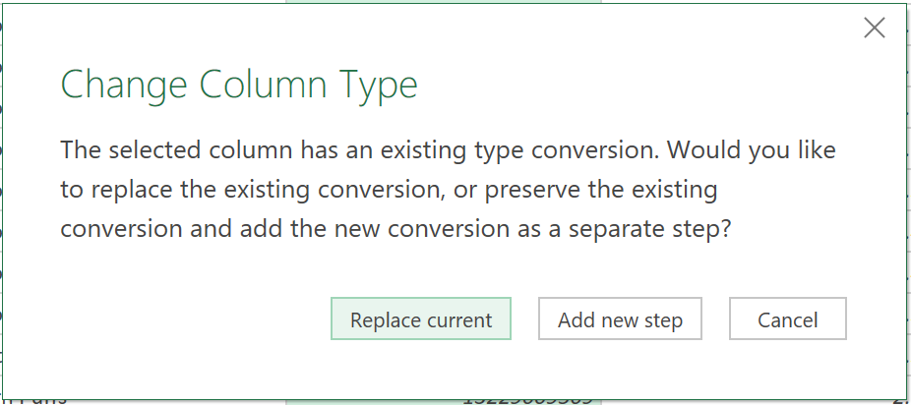



Replace both product_retail_price and product_cost to currency.

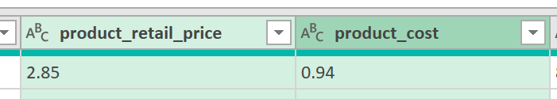



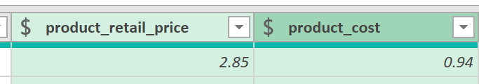



There are statistical functions that are not used for transformational purposes but only for exploratory. For example, suppose you want to know how many unique products are there.

Highlight product_brand column, Transform tab, Statistics, Count Distinct Values

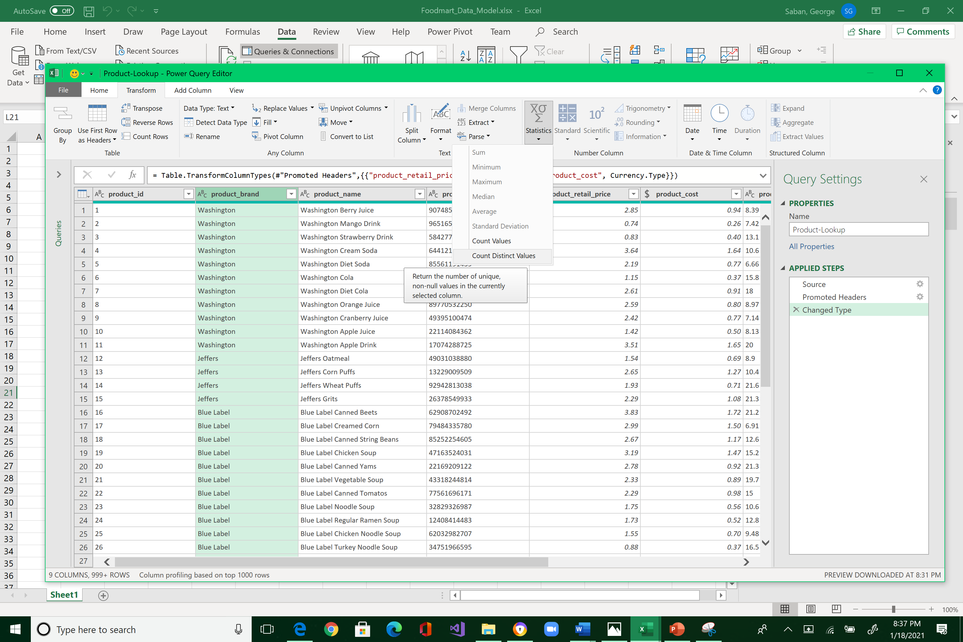



The answer is 111

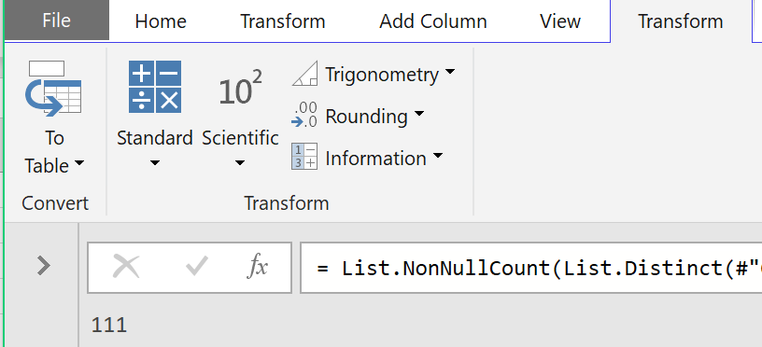



Note that the answer is only one value and not added as a column in the table. This is the reason why statistical functions are not transformative, but only for experimental purposes. Delete the last calculation step by pressing the “x” icon. This will bring you back to the Power Query Editor.

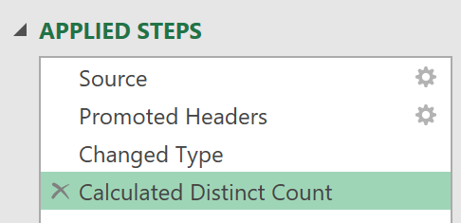



Now, calculate the average retail prices—the answer should be 2.11728…

Hints are below. Also, make sure you delete your last step to bring you back to the Power Query Editor.

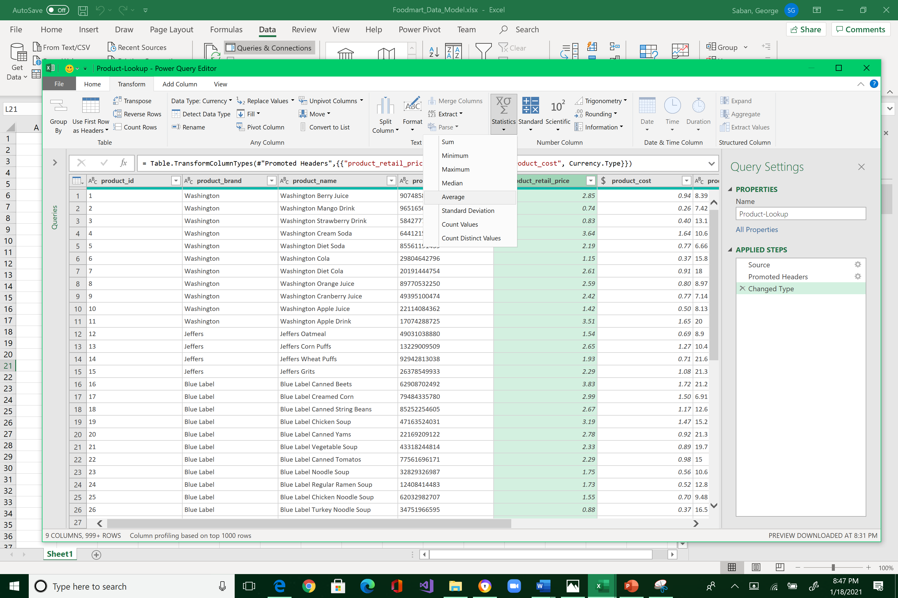



Let's say that the company runs a 10% off discount deal. Highlight product_retail_price, click Add Column tab, Standard, Multiply, type 0.9 under the Value textbox (i.e., 90% of the original price), and click OK.

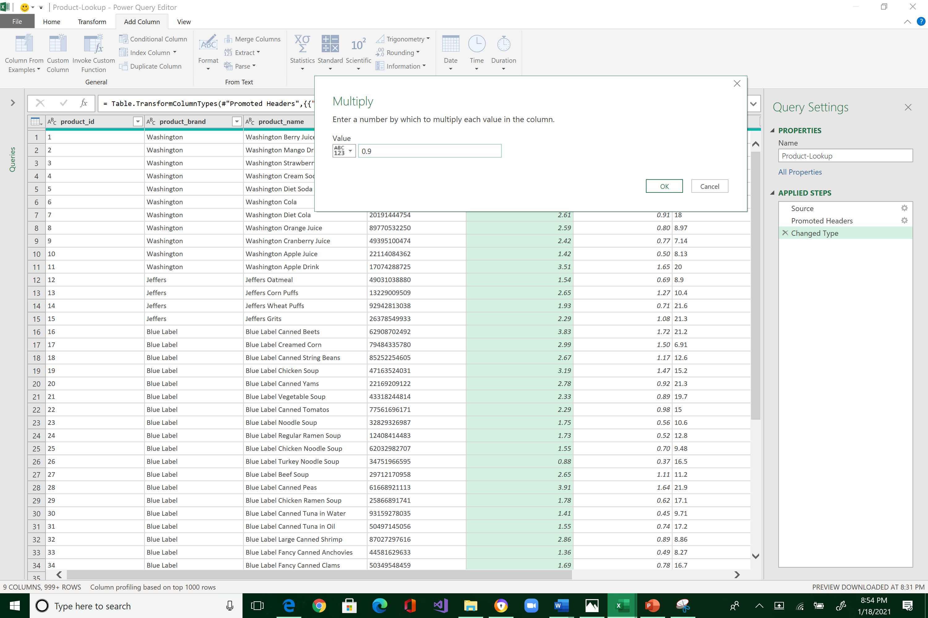



Note the addition of a new column.

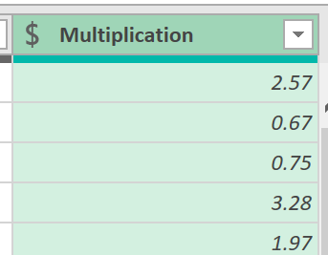

Rename the new field to discount_price (you already know how to do this in previous exercises: hint, double click).

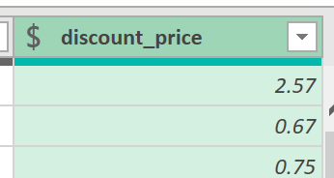

By now, you see that the tools (Text and Numbers) in the Power Query Editor are straight forward and super easy to use. The only way to be comfortable with them is to play with these options. Try every feature, observe what it does, and then delete it. Discarding applied steps is easily achieved through the Applied Steps pane.

It is now time to load this data. Click the Home tab. It is very important that you select the small arrow-down icon next to the Close & Load, and not the Close & Load button. Please redo your work if you make this mistake.

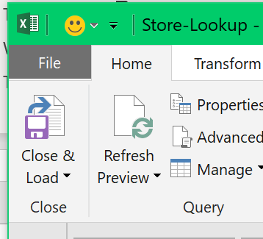



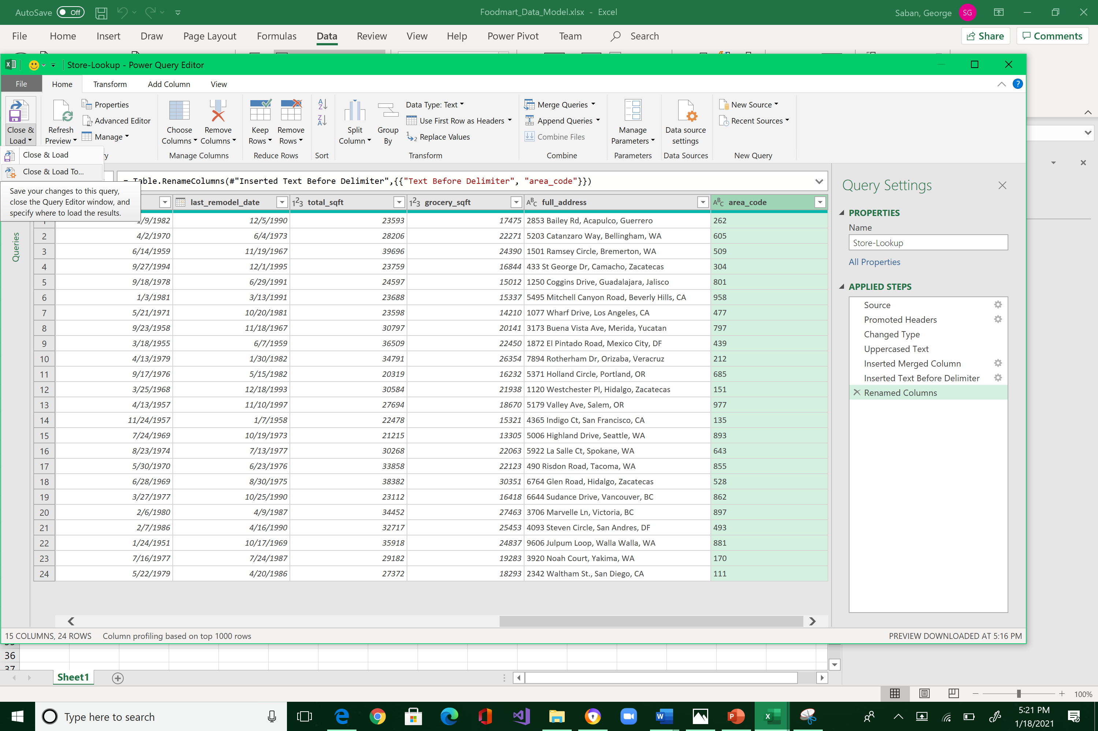



Select “Only Create Connection,” and “Add this data to the Data Model” options inside the Import Data window. Click OK.

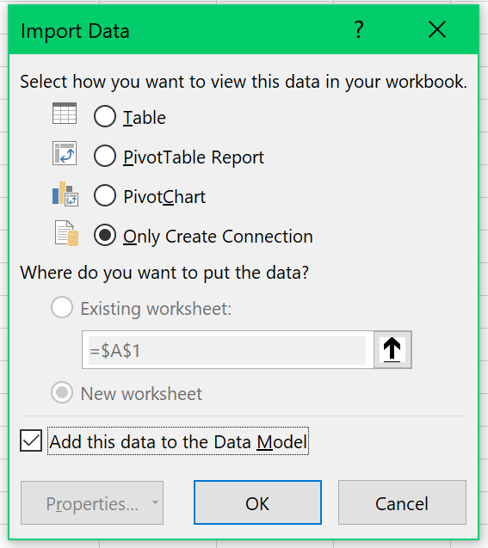



Note the 1,560 rows loaded into your Data Model.

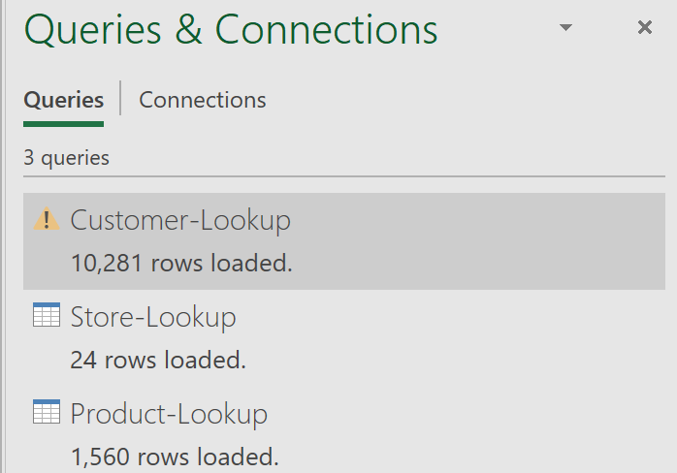



To verify your new table, click Power Pivot, Manage

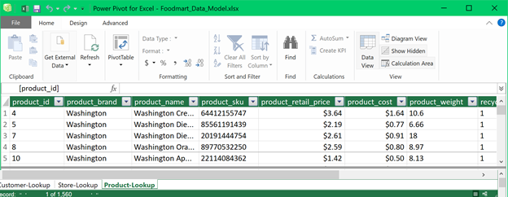



Make sure that the changes are applied: discount_price

Save your work by closing the Data Model screen and go back to Excel. Click File, Save.

After you save your work:

1. Resize the Excel spreadsheet and take a snapshot using Window's Snipping Tool.
2. Make sure the system's date, your name, and the number of rows loaded are included in the image.
3. Submit to Canvas in PNG format.

